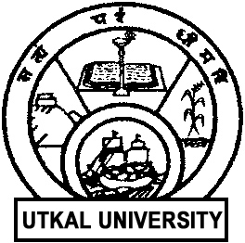 | UTKAL UNIVERSITY  Vani Vihar, Bhubaneswar - 751004

Date:30.04.2026
Public Relation Officer / Documentation Officer of Utkal University, Odisha.
With reference to Adv.No. DRS/RUSA-1041-2016(HR)/3642/2026 Dtd:31.03.2026, the walk in interview for empanel of Human Resource under RUSA2.0 is schedule to be held on 5th May 2026 at 11.00 am in the IQAC Hall New Administrative Building Utkal University.
The Candidates may walk in for the Interview with hard copy of the application, self-attested photocopies of mark-sheets, certificates and other relevant documents in support of applications with original certificate.

