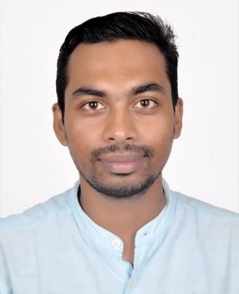

**Mr. Biswajit Sahoo**

**Designation:** Guest Faculty

**Qualification:** M.Com, M.Phil, UGC-NET

**Date of Birth:** 14.03.1997

**Tel:** 8249584575

**Email:**biswajit1403@gmail.com

**ORCID:** <https://orcid.org/0009-0004-1325-6870>

**VIDWAN:** [**https://vidwan.inflibnet.ac.in/profile/404534**](https://vidwan.inflibnet.ac.in/profile/404534)

Area of Interest

Financial Accounting and Financial Market

Courses taught

Corporate Financial Accounting, Advance Accounting, Financial Market, Human Capital Development, Financial Modeling and Valuation, Business Econometrics, Corporate Reporting Practices

Career

Guest Faculty (2022-2024): Rama Devi Women’s University, Bhubaneswar

Guest Faculty (2024- Continue): Utkal University, Bhubaneswar

**Teaching Experience** 2years 6 Months

Research Guidance

* M.Com thesis supervised :**08 (Eight)**

Participation in Conferences& Seminars:

1. Presented a paper titled **“Contemporary issues and challenges in Accounting”** in National Seminar organized by Department of Commerce, Utkal University held on 1stApril 2018.
2. Presented a Paper titled “**Digitization and Banking sector: An Empirical Study”** in Seminar organized by All India Accounting Association, Bhubaneswar branch in collaboration with MIMTS, Khordha on 18th November, 2018
3. Presented a paper titled **“Impact ofFair value measurement on the profitability of companies: An empirical study between AS and IndaAs”** in National Seminar organized by Department of Commerce, Utkal University held on 3rdand 4thFebruary 2019.
4. Presented a paper titled **“Triple Bottom Line” As a practical framework of corporate sustainability”** in National Seminar organized by DAV school of Business Management Bhubaneswar held on 20 November2022
5. Presented a paper titled **“Triple Bottom Line” As a practical framework of corporate sustainability”** in National Seminar organized by Department of Commerce, Utkal University held on 26 March 2023
6. Presented a paper titled, **“Role of Artificial Intelligence in Implementation of Goods and Services Tax(GST) and Future Scope”** at 43rd Annual Conference of Orissa Commerce Association and National Seminar Organized by Rama Devi Women’s University, Bhubaneswar, Odisha, held on 22nd and 23rd December, 2023.
7. Presented a paper titled, “" **An Evaluative study on impact of Green Technology enabled strategies on Sustainable Development**” in Two-Days National Seminar on the theme “Start-Ups and Sustainability for Developed India: Issues and Challenges” held on 29th and 30thMay, 2024 in the P.G. Department of Commerce, Utkal University, Bhubaneswar.