UNIT 2 CONSUMER BEHAVIOUR AND LIFESTYLE MARKETING

Objectives

After reading this unit you should be able to :

define the concept of lifestyle marketing

describe the role of lifestyle analysis and other approaches to study of consumer behaviour.

identify the characteristics of lifestyle

learn about AIO inventory and VALS classification used in "Lifestyle Analysis"

get a glimpse of lifestyle studies in India

describe current applications and trends in lifestyle marketing.

Structure

2.1 Introduction

2.2 Demographics, Psychographics and Lifestyle

2.3 Characteristics of Lifestyle

2.4 Influences on Lifestyle

2.5 Approaches to Study Lifestyle

2.6 Application of AIO Studies

2.7 Lifestyle Profiles in Indian Context

2.8 VALS System of Classification

2.9 Applications of Lifestyled Marketing

2.10 Summary

2.11 Key Words

2.12 Self-assessment Questions

2.13 Further Readings

2.1 INTRODUCTION

Lifestyle marketing is a process of establishing relationships between products offered in the market and targeted lifestyle groups. It involves segmenting the market on the basis of lifestyle dimensions, positioning the product in a way that appeals to the activities, interests and opinions of the targeted market and undertaking specific promotional campaigns which exploit lifestyle appeals to enhance the market value of the offered product. The Marketing Dictionary of Rona Ostrow and Sweetman R. Smith describes lifestyle as "a distinctive mode of behaviour centred around activities, interests, opinions, attitudes and demographic characteristics distinguishing one segment of a population from another. A consumer's lifestyle is seen as the sum of his interactions with his environment. Lifestyle studies are a component of the broader behavioural concept called psychographics." Harold W. Berkman and Christopher Gilson define lifestyle as "unified" patterns of behaviour that both determine and are determined by consumption. The term "unified patterns of behaviour" refers to behaviour in its broadest sense. Attitude formation and such internal subjective activities may not be observable, but they are behaviour nonetheless. Lifestyle is an integrated system of a person's attitudes, values, interests, opinions and his over behaviour.

2.2 DEMOGRAPHICS, PSYCHOGRAPHICS AND LIFESTYLE

Demographic variables help marketers “locate" their target market and psychographic variables provide the marketer with more insight about the segment. Psychographics is, in common parlance, lifestyle analysis or AIO research. In its most widely practised form, a psychographic study consists of a long list of statements designed to capture relevant aspects of a consumer, like personality, hinting motives, interests, attitudes, beliefs and values. When the study becomes oriented towards a particular product, the consumers have to respond to statements which are selected for the purpose i.e. on products, brands, services, competitive situations etc.

The demographic and psychographic lifestyle approaches are highly complementary and work best together. People hailing from the same sub-culture, social class and even occupation follow quite different lifestyles. He / She may choose to have a "belonging" lifestyle, which will be reflected in his / her wearing conservative clothes, spending considerable time with her family and participating in social activities. Or she can be an "achiever" marked by an active personal life and playing hard when it comes to travel and sports. It can be seen that lifestyle depicts the “whole person" in active interaction with his environment.

The lifestyle analysis adds a great amount of understanding to a typical demographic description. A person buying a new designer shirt may be 34 years old, married and living in a three bedroom house and having 2 children. The lifestyle analysis would help marketers to paint a more human portrait to their target market.

For instance the "young, upwardly mobile" lifestyle group cutting across sub-cultures, social class, occupation etc. is now being increasingly used by Indian marketers as their market group. This finds its expression in advertising appeals "He loves the feel of the city... The skyscrapers... The crowds... The pretty faces... And the heedy feeling of being successful... Above all the freedom of being himself." So says the advertisement for Pantaloon cotton trousers from Manz Wear. Another advertisements for men's underwear from Bhilwara loudly announces "for the man who plays many roles-here comes the very best in wearunders via the grand fashion avenues of Paris...Champs Elise". The behavioural differences between prospects that do not show up in demographic figures come alive in lifestyle patterns. Lifestyle, analysis leads to more comprehensive and penetrating profiles of how consumers think and act than may be available from other approaches.

2.3 CHARACTERISTICS OF LIFESTYLE

Feldman and Theilbar describe lifestyle by the following characteristics:

1 Lifestyle is a group phenomenon - A person's lifestyle bears the influence of his/her participation in social groups and of his/her relationships with others. Two clerks in the same office may exhibit different lifestyles.

2 Lifestyle pervades various aspects of life - An individual's lifestyle may result in certain consistency of behaviour. Knowing a person's conduct in one aspect of life may enable us to predict how he/she may behave in other areas.

3 Lifestyle implies a central life interest - For every individual there are many central life interests like family, work, leisure, sexual exploits, religion, politics etc. that may fashion his interaction with the environment.

4 Lifestyles vary according to sociologically relevant variables - The rate of social change in a society has a great deal to do with variations in lifestyles. So do age, sex, religion, ethnicity and social class. The increase in the number of double income families and that of working women have resulted in completely different lifestyles in the 1980's in India.

2.4 INFLUENCES ON LIFESTYLE

Cultural and societal variables establish the outer boundaries of lifestyle specific to our culture. The interaction of group and individual expectations and values creates a systematic pattern of behaviour. This is the lifestyle pattern that determines purchase decisions. When goods and services available in the market are in tune with lifestyle patterns and values, consumer market reactions are favourable. And purchases that reinforce these patterns further illuminate these lifestyles. Lazer's lifestyle hierarchy brings out these interactions.

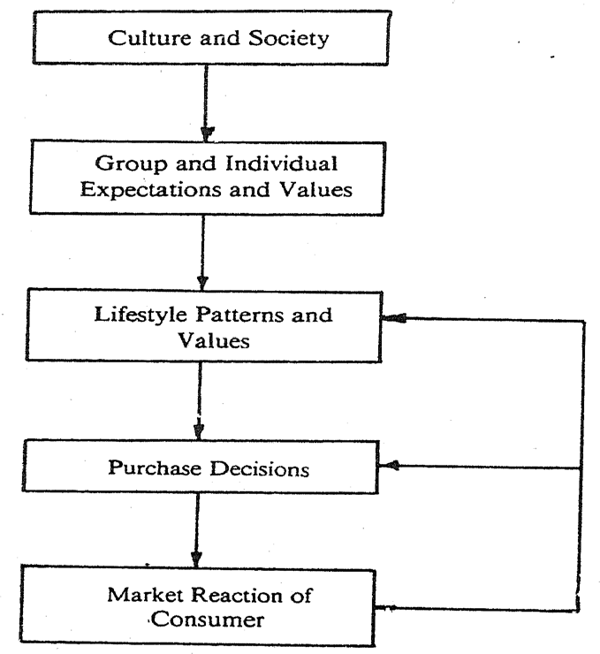

Figure 1 : Hierarchy of Influences on Lifestyles

2.5 APPROACHES TO STUDY LIFESTYLE

The study of lifestyle is interdisciplinary. It draws on a variety of disciplines such as anthropology, psychology, sociology and economics. Marketing uses this eclectic approach for segmenting, targeting and positioning which forms the core of marketing strategy. Because lifestyle refers to the way in which people live and spend money, consumers psychographic profiles are derived by measuring different aspects of consumer behaviour such as:

1 Products and services consumed

2 Activities, interests and opinions

3 Value systems

4 Personality traits and self-conception

5 Attitude towards various product classes

Many approaches are available to the study of psychographic variables. One of the ways is to study the lifestyle variables by an AIO inventory for use in segmenting, targeting and positioning. Another lifestyle approach is by using VALS typology. We will expand on these concepts now.

AIO Inventories - AIO studies envisage a wide variety of variables and measures the major dimensions shown below :

Activities Interests Opinions Demographics

Work Family Themselves Age

Hobbies Home Social Education

Social events Job Politics Income

Vacation Community Business Occupation

Entertainment Recreation Economics Family size

Club member Fashion Education Geography

Community Food Products City size

Shopping Media Future Lifecycle

Sports Achievements Culture Dwelling

Source : Joseph T. Plummer--The Concept and Application of Lifestyle Dimensions, Journal of Marketing.

Let us take a closer look at these variables :

• What are activities? Activities indicate how a consumer/family spends his/her/their time.

• What are interests? Interests are a family's or consumer's preferences or priorities.

• What are opinions? Opinions are how a consumer feels about a wide variety of events and things.

In order to explore an individual’s activities, interests and opinions, respondents are given lengthy questionnaires in which they are asked how strongly they agree or disagree with statements such as: I would like to become an actor I usually dress for fashion and not for comfort A woman's place is in the house I-often have drinks before dinner I love the outdoors. The statements can be general or product-specific. They can be pertaining to individual or family/household. For instance, the classifications of different type of Psychographic statements for traveller’s cheques are given below: In constructing an inventory of such lifestyle statements researchers first go through market research studies that might be of help in isolating psychographic variables. Motivation research studies which reveal consumer's reflections on their experiences and needs are a good source. Based on such reviews psychographic statements are prepared which bring out the range of activities, interest and opinions that the researcher wishes to evaluate. In constructing a psychographic inventory, it has to be thoroughly assessed whether consumers will understand the meaning of the each of the statements as the marketer expected them to be interpreted. It is also important to avoid statements that lead consumers to make a socially acceptable response which really does not reflect their true feelings or likely ways of interaction with environment. In responding to an inventory as explained above consumers are usually asked to rate in a quantifiable rating scale as is used in marketing research studies, the extent of their agreement or disagreement with each statement and results are statistically evaluated. Thus psychographic research produces quantifiable insights that are usually presented in tabular format. The measurement is similar to the measurement of personality traits in that it requires the use of self-administered questionnaire or inventories.

VALS – Values, attitude & lifestyle
The acronym VALS, (for "Values, Attitudes and Lifestyles") is a psychographic segmentation. ... The main dimensions of the segmentation framework are primary motivation (the horizontal dimension) and resources (the vertical dimension). The VALS approach is derived from a theoretical base in Maslow's work (1954).
The VALS framework is used in marketing to segment customers based on their values, attitudes and lifestyles. It is a qualitative methodology used to understand how consumers think. This way you can create more effective messages focused on their interests. If you want to apply this technique to your project, download this editable template from Slidesgo. It contains info-graphics that will help you develop the VALS method, with tables, graphs and matrixes that will be of great help
Vals which is also known as values attitude and lifestyle is one of the primary ways to perform psychographic segmentation. All three terms are intangible in nature and therefore give an idea of the inert nature of the consumer. If you know what your consumer is thinking, you would know what kind of promotions or communications will attract him most. And how do you know what the consumer is thinking? By determining his vals – Values, attitudes and lifestyle.
VALS is different for different people. Lets take income as an example. If you are a person with high income your lifestyle would probably include habits of the SEC A class such as dining out of home frequently and that too in top class restaurants, wearing only branded clothes and buying the best cars out there. Whereas if you are a middle class income group consumer, you would be more wary of spending money and would rather concentrate on savings.

So now how does VALS affect a marketer? Lets say you were a banker. What would you sell someone who had a high income lifestyle? You would sell them investment options and would also dedicate a relationship manager to take care of their needs. In fact, the bankers also have a term for high income individuals known as HNI – high net worth individuals. But, if your lifestyle was that of a low income customer, you are more likely to be targeted for savings

ALS is a marketing tool used to predict consumer behaviour based on their philosophical beliefs, mechanical and intellectual curiosity, among other things. VALS stands for ‘Values and Lifestyles and is a series of questions to help define target audiences. The audiences are divided into nine lifestyle types: innovators, thinkers, achievers, emulators, achievers, strivers, experiences, makers, and survivors. Each type is thought to behave and consume differently.

To any business who is seeking to find more details about their audience, there are several ways you can apply the VALS methodology of which we will explain here.

Using VALS methods in customer surveys

One method of using the VALS methodology to determine the direction a business should take is to survey your market and customers. If you can convince enough of your target market to complete a VALS survey, you can then use the data to determine how strong your customers lean toward their wants and spending behaviours. If your customers are primarily innovators or thinkers, they will consume quite differently than someone who is maker or survivor. With this data, you can then determine if your brand should take a new direction. A brand like Nike likely applied a similar strategy when determining their buying audience was more in line with a younger, more socially conscious customer base than the survivor, for example.

Using VALS to create a product

Another method of applying VALS methodology to a marketing strategy is in product creation. If you seek to attract a certain audience, you can use VALS as the basis for brand and product creation. You then can reverse engineer the results. If you want to attract an innovator or thinker and are in the tech industry, you would want to create products and market them like how Apple runs its company. However, if you are wanting to attract a maker or survivor, you would want to go more along the lines of practicality and functionality rather than design and high-end features.

Personally, I find VALS to be fairly limiting, as most people do not fit into clearly defined categories and are more likely complex beings that make a variety of statistically irrational decisions. So, while VALS may be an excellent tool for a broad market, people should be careful to not assume these results fully define the consumer audience, again, as the Nike Kaepernick ad also did.

I took the test and it said I am primarily a maker and second an experiencer. While this is true, the results seem to be almost like a sort of astrology for marketers. Just vague enough to apply no matter what. Because while these apply to me, I can also say pretty much all the types apply to me to some extent and generalizing a mass market in this way can be misleading. In conclusion, I would say that while VALS is a good source for brand identity and for targeting audiences, it is far from a universal perfect targeting system that you can expect any audience to believe in.

History of the term VALS
VALS is actually a proprietary term of SRI international. The term was developed by Social scientist and futurist Arnold Mitchell. Arnold Mitchell actually developed the VALS framework to determine different classes of people who had varying values, attitudes and lifestyle. These people were determined by the resources they had at their disposal as well as the amount of primary innovation they could accept or create. Thus the people with low resources were low on innovation and the ones with higher resources were higher in innovation. This formed the basis of the VALS framework.

The VALS framework
As mentioned in the history of VALS, The VALS framework was developed keeping a consumers resources as well as his capacity to accept innovation in mind. The X axis consisted of primary motivation (explained below) and the Y axis consisted of resources such as income, education, confidence etc. Thus these two factors were determined to be critical to define the values attitude and lifestyle of any consumer.
- Resources – Included resources available to an individual such as income, education, intelligence, emotional support, etc.
- Primary motivation – Which determined what actually drives the individual. Is it knowledge, the desire to achieve something or is it to be social.
After researching above 1500 consumers, Arnold mitchell actually divided consumers into 9 different types based on the amount of resources they had as well as their capacity for primary motivation. These classes of consumers based on their VALS were.

9 types of Consumers as per VALS framework
- Innovators – The class of consumer at the top of the VALS framework. They are characterized by High income and high resource individuals for whom independence is very important. They have their own individual taste in things and are motivated in achieving the finer things in life.
- Thinkers – A well educated professional is an excellent example of Thinkers in the vals framework. These are the people who have high resources and are motivated by their knowledge. These are the rational decision making consumers and are well informed about their surroundings. These consumers are likely to accept any social change because of their knowledge level.
- Believers – The subtle difference between thinkers and believers is that thinkers make their own decisions whereas believers are more social in nature and hence also believe other consumers. They are characterized by lower resources and are less likely to accept innovation on their own. They are the best class of word of mouth consumers.
- Achievers – The achievers are mainly motivated by – guess what – Achievements. These individuals want to excel at their job as well in their family. Thus they are more likely to purchase a brand which has shown its success over time. The achievers are said to be high resource consumers but at the same time, if any brand is rising, they are more likely to adopt that brand faster.
- Strivers – Low resource consumer group which wants to reach some achievement are known as strivers. These customers do not have the resources to be an achiever. But as they have values similar to an achiever, they fall under the striver category. If a striver can gain the necessary resources such as a high income or social status then he can move on to becoming an achiever.
- Experiencers – The group of consumers who have high resources but also need a mode of self expression are known as Experiencers. Mostly characterized by young adults, it consists of people who want to experience being different. This class of consumers is filled up with early adopters who spend heavily on food, clothing and other youthful products and services.
- Makers – These are consumers who also want self expression but they are limited by the number of resources they have. Thus they would be more focused towards building a better family rather than going out and actually spending higher amount of money. Making themselves into better individuals and families becomes a form of self expression for the Makers.
- Survivors – The class of consumers in the Vals framework with the least resources and therefore the least likely to adopt any innovation. As they are not likely to change their course of action regularly, they form into brand loyal customers. An example can include old age pension earners living alone for whom the basic necessities are important and they are least likely to concentrate on anything else.
Thus the vals framework can be used primarily to classify consumers based on their values, attitudes and lifestyle. Once the classification has been done, you know which types of customers you want to target. Depending on your target customers vals, you can make up your marketing strategy and your promotional message such that it hits your audience at the right spot.

Lifestyle Segmentation
Segmentation is an integral part of marketing strategy of any organization for any product. It is important to know the different segments that exist in the possible target customers to ensure that a product is positioned to the right segment of people. It actually means dividing a market into sub-segments and each segment have something in common.
It helps in identifying a different set of people who are interested in different products and look for specific featured or prices in a product. This segmentation can further be understood and segregated on the basis of various dividing identifiers like geographic, demographics, and many more.
Among the various types of segmentation, lifestyle segmentation holds its value in a unique way. As the word suggests, lifestyle means the way of living a consumer is pursuing and then based on these ways of living they are grouped to form the lifestyle segment. The importance of lifestyle segmentation comes at two very important phases of the lifecycle of a product.
The study of the lifestyle of consumers helps the marketers understand the right need of customers so making a decision about what product should be targeted to which customer set becomes easy. And another significant phase is the product communication as it tells what communication message needs to be portrayed in front of the target audience to ensure they can relate to it.
Lifestyle segmentation helps in understanding the customer requirements better and based on which marketers can take appropriate decisions of rightly placing the products in the right market segments.
The lifestyle of consumers consists of many aspects and to do the segmentation on this basis, it is important to understand these different aspects. These aspects help in delivering the customized services and good quality products. These lifestyle aspects are majorly divided into below as per the commonly used tool called AIO (Activities, Interests, and Opinions):-
- Activities – What are the daily activities of the consumers in which they are spending their time and money?
- Interests – What are the interest of consumers?
- Opinions – What do they think about various issues, people, and surroundings?
- Demographics – What category in terms of age groups, gender, income, and occupation they belong to?
All the above aspects are important to define the lifestyle of consumers and finally to come up with the lifestyle segmentation. Let us now understand the AIO with examples.
Activities of consumers help a marketer in understanding the kind of work a consumer does or the ways he/she keeps him/her indulged on a daily basis like work, hobbies, social events, vacations, entertainment, club membership, community, and many more.
These activities decide the person’s routine for e.g. if we have a sales guy whose job involves a lot of traveling on a daily basis then we know that his work is exposing him with a lot of outdoor activities. On the other hand, a person who works in a BPO will be the one who is sitting and talking to people regularly. There will be a huge difference between these two types of people and similarly multiple profiles can be generated on the basis of the activities that a consumer performs daily.
Interests are the next part of understanding a customer’s lifestyle. A consumer may have multiple interests like someone may like to go out and see movies, on the other hand, another person may like to watch live sports for entertainment.
Interests can be in any form or towards any particular thing like family, home, job, community, recreation, fashion, food, and other areas of interest. These are an important factor for a marketer to decide what is the next thing that a consumer is looking for and finally to have the right kind of segmentation.
Then comes the Opinions which again different people will have different on various topics of general availability all around. These opinions may be related to anything social issues, themselves, politics, business, economics, education, products, etc. Suppose a consumer is very much attached to a particular social issue and a promotional campaign involves the negative side of that social issue, then as a marketer, you immediately lose the interest of that particular consumer.
Culture, emotions, and family values are really very important, it becomes a significant deciding factor when segmenting the customers in a category.
VALS – II
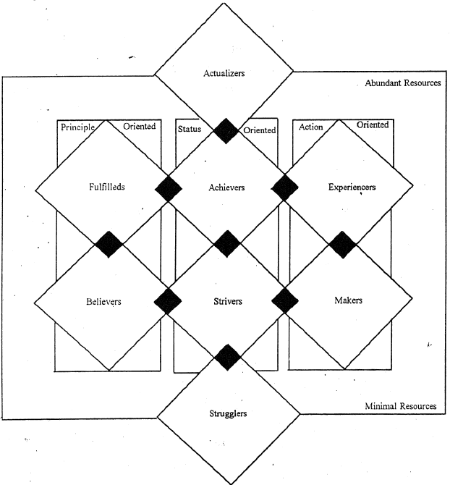
A modified version of VALS-I is VALS-II, where the VALS-II typology draws heavily on Maslow's need hierarchy and tries to explain the lifestyle orientation of the various segments based on the values sought by each of them in their life.

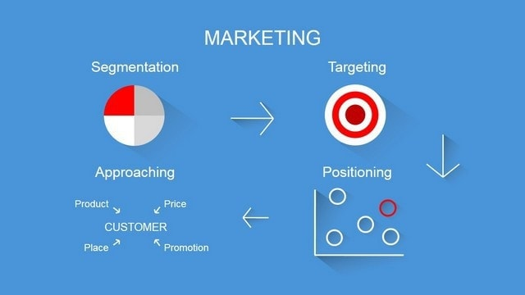

Lastly, demographics are an important part of any kind of segmentation and for lifestyle segmentation as well these play theirs as a usual vital role. What age-group a marketer is talking about, what are the gender of the prospective consumers, which geography they belong to, their occupation, and income levels always help in deciding up a direct customer-oriented strategy for marketers?
Therefore, as marketers, the most important thing to remember is that lifestyle analysis is an ongoing process. The interests, activities, opinions, and demographic changes with time and situation. Everything in this dynamic world takes a shift, groups with something else, changes due to various factors, and tastes are continuously changing.
New trends and social changes determine what the consumers will pick to do next. Hence, it becomes utmost important to keep an ardent eye on all dynamics and continuously change strategies according to these changing factors. Lifestyle segmentation is periodic, consistent, and never-ending.

