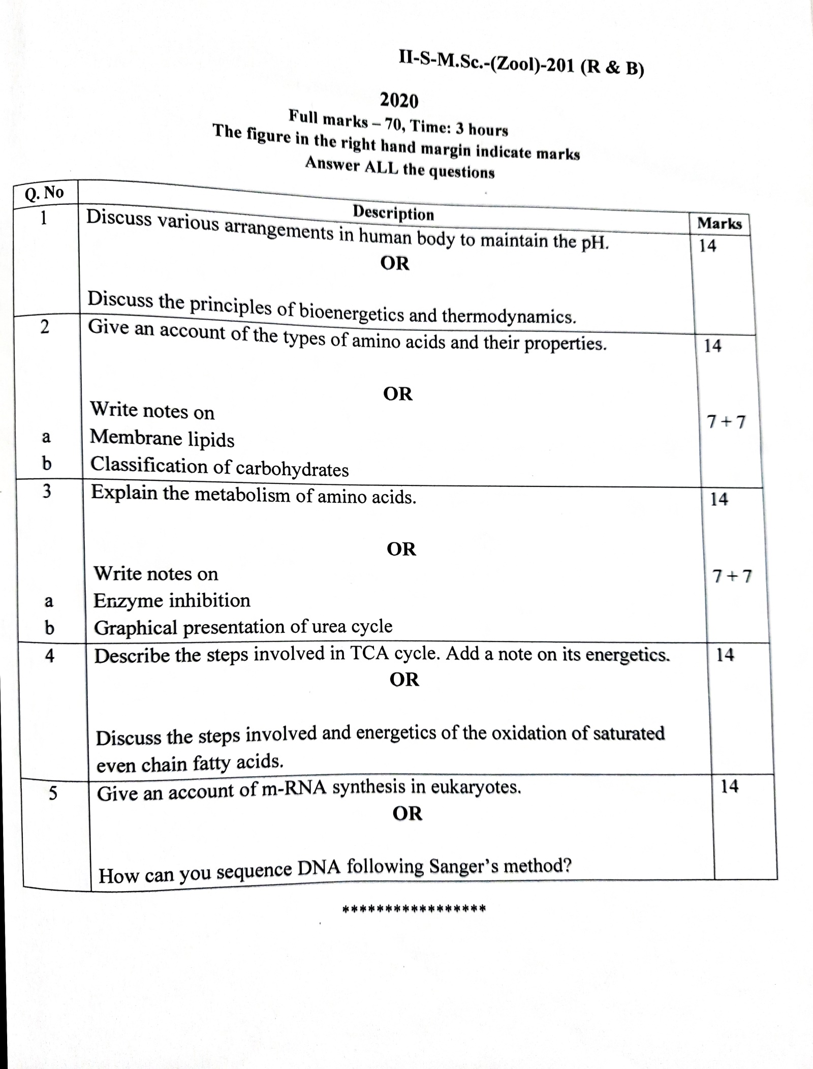

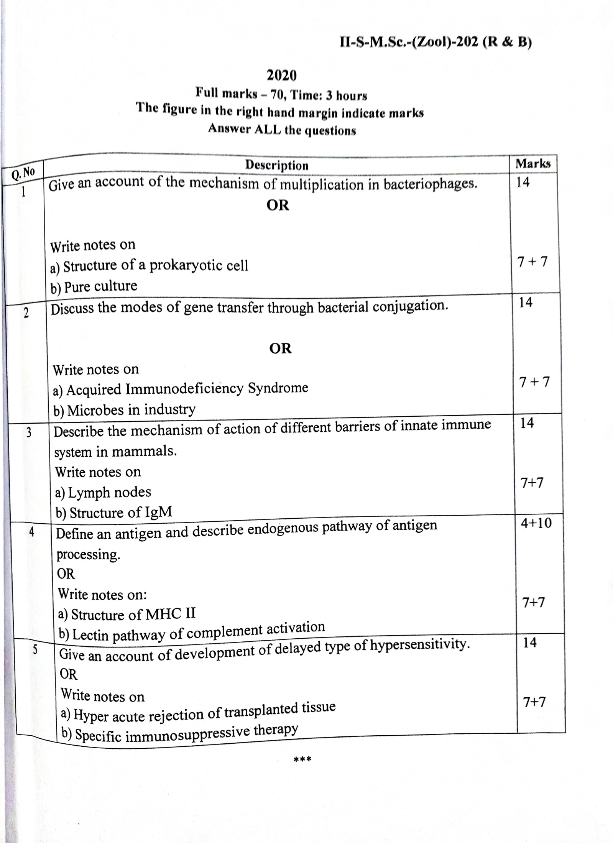

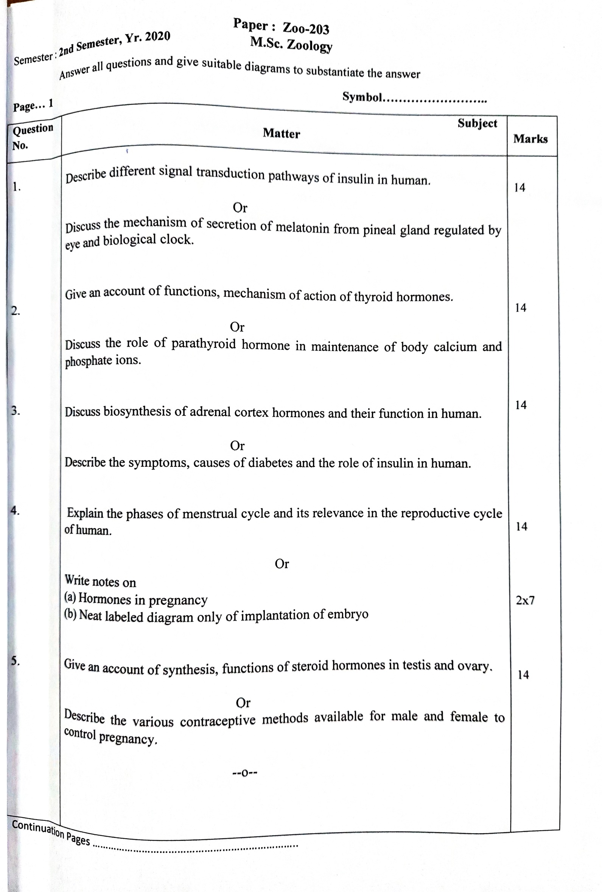
Paper : Zoo-204 Semester : 2nd Semester, Yr. 2020 M.Sc. Zoology
Answer all questions and give suitable diagrams to substantiate the answer
Page… 1 Symbol……………………..
Ref. if any | Question No. | Subject Matter | Marks
 | 1.  2.  3.  4.  5. | What is Hardy-Weinberg equilibrium? Describe the derivation of its equation, conditions influencing the equilibrium and applications of this law.  Or  Define biological species concept. Discuss with examples different patterns of speciation.  -  Define microevolution. Discuss the evidences in support of microevolution and causes of microevolution seen in nature.  Or  Discuss the molecular cause of gene duplication and outcome of gene duplication in a population.  Describe the proposition, applications, evidences of neutral theory of evolution and discuss the use of this theory in formation of molecular clock.  Or  Define gene. Describe different mechanism of evolution of a gene.  Give an account of different rhythmic behavior due to biological clock with examples in animals.  Or  Write a note on altruism and kin selection in animals.  Discuss with examples parental care of amphibians  Or  Give an account of social communication in honey bee.  --0-- | 14  14  14  14  14
Continuation Pages ……………………………………………………………..

