FORMAT (For Research Supervisor): PSYCHOLOGY
1.Name: DR.JASHOBANTA MAHAPATRA
2.Mobile No./ Email ID: 9938587143, 9437256903 / jashobanta.orissa@gmail.com
Postal Address: DEPT. OF CLINICAL PSYCHOLOGY, MENTAL HEALTH INSTITUTE (COE), S.C.B. MEDICAL COLLEGE & HOSPITAL, CUTTACK- 753007, ODISHA
3.Designation: ASSOCIATE PROFESSOR & H.O.D, DEPT. OF CLINICAL PSYCHOLOGY
4.Work Under: HEALTH & F.W. DEPARTMENT, GOVT. OF ODISHA
5. Years of Service: 21 YEARS
6. Date of Retirement: 31.01.2027
7.No. of Ph.D Scholars working under active supervision: 05 (Under process of registration)
8.Name of the Scholars with date of Registration (if any): (Under process of registration)

1. SUSHREE SANGITA BEHURA
2. PRASANTA KUMAR SETHI
3. SAMPEET MAHANTY
4. MANISHA MISHRA
5. SAILABALA MISHRA

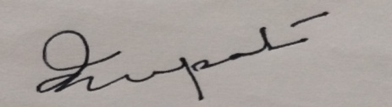
(Dr.Jashobanta Mahapatra)
Signature of the Supervisor
Dt.25.07.2020

